
c

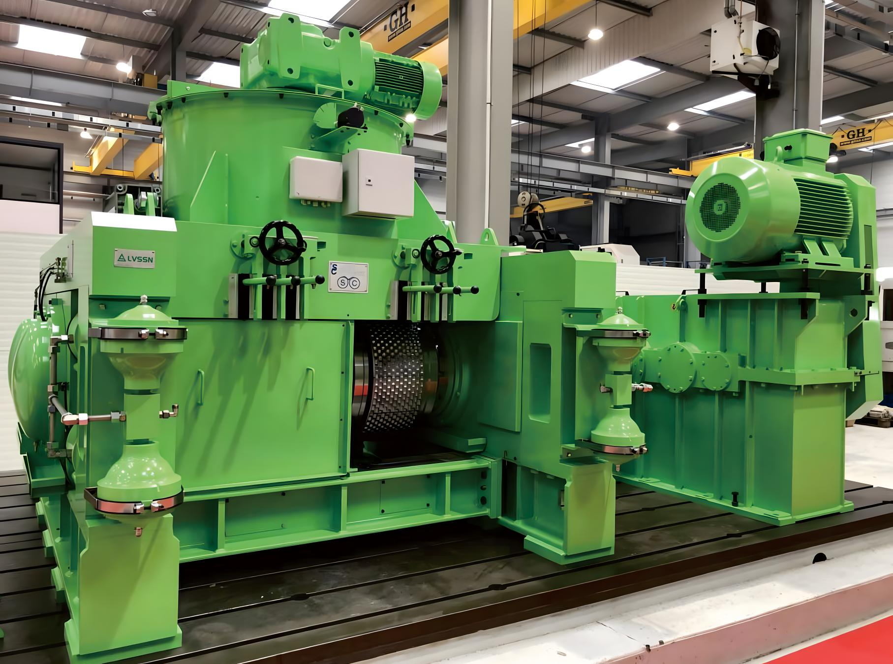



LVSSN QUOTATION
RAW MEAL GRINDING RECONSTRUCTIONPROJECT OF SAFI

July 16th,2025

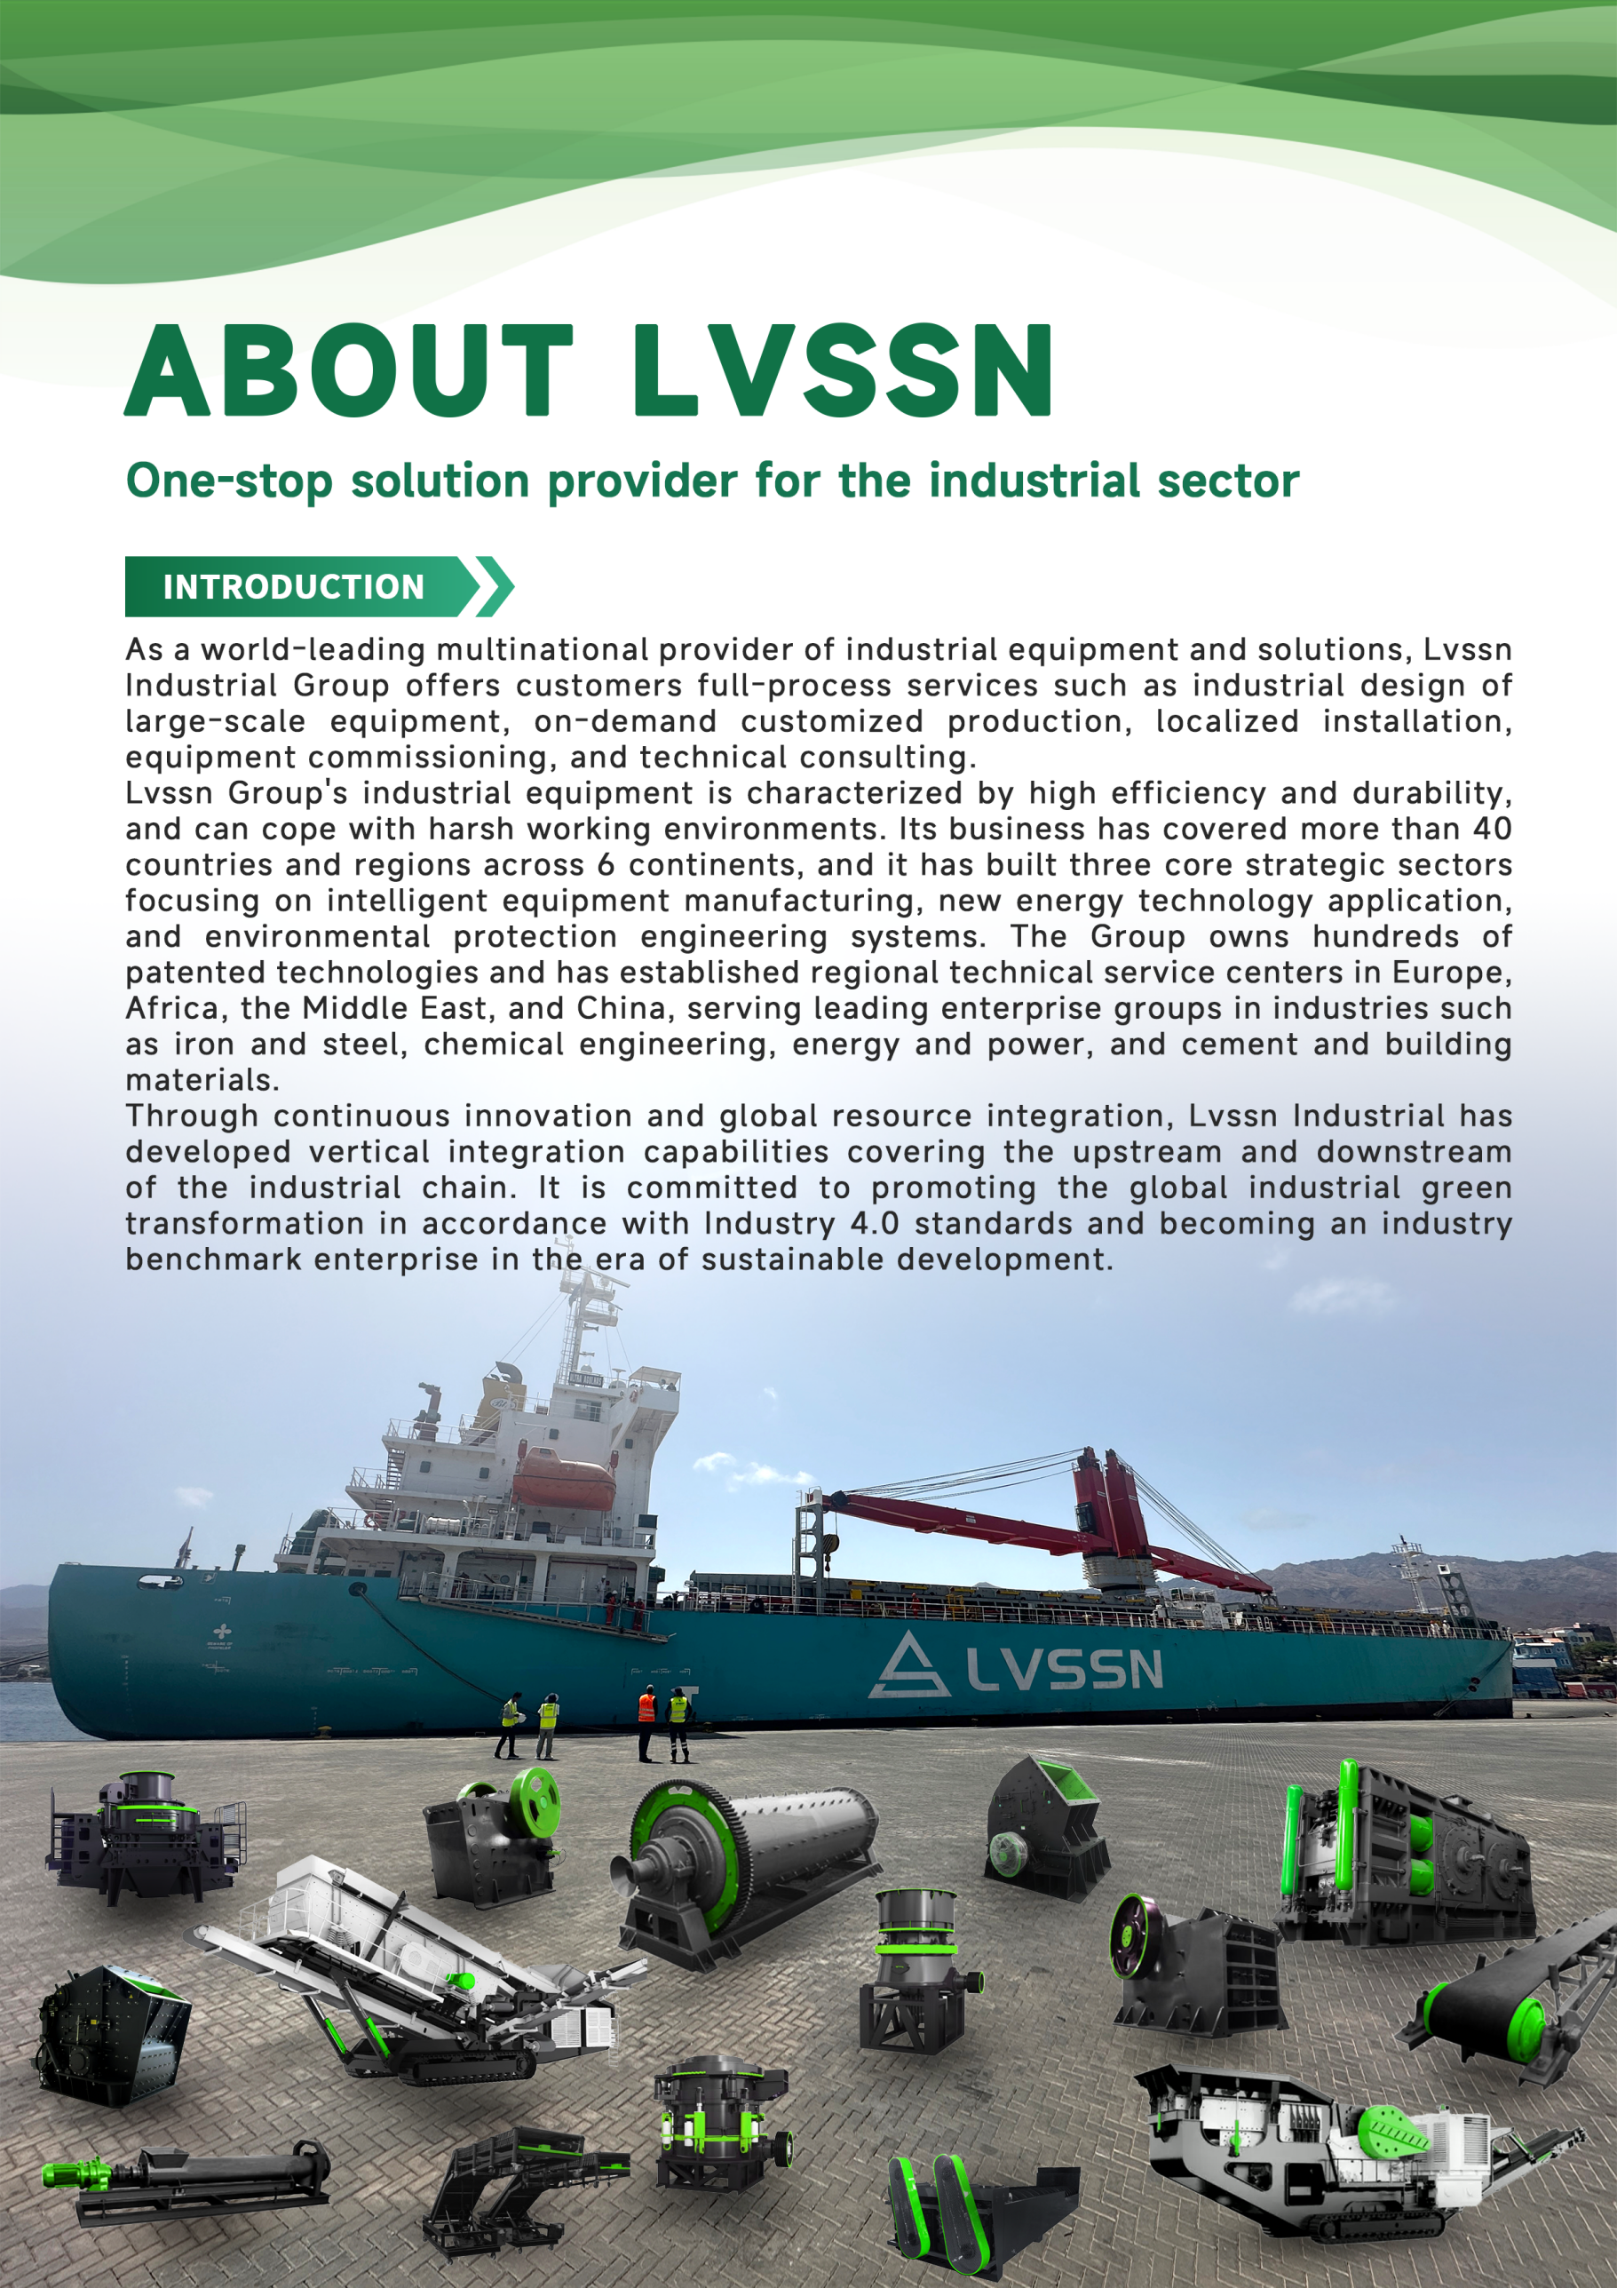

CONTENYTS
Chapter 1:Project Information 4
Chapter 2:Solution and Design 4
Chapter 3:Configure List 9
Separator 9
Cyclone 10
Circulating Fan 10
Chapter 4:Bill of Quantities 11
Chapter 5:Equipment Suppliers List 12
Chapter 6:Corporate Performance 12
International Projects Contraction 13
Domestic(Recent) Project Contraction 14
Chapter 7:Quotation 15
Chapter 8:Construction Schedule 15
Chapter 9:Payment Terms 16

Chapter 1:Project Information
- Project Name: 280TPH Raw Material Roller Press Renovation Project.
- Upgrading Target:≥280t/h.
- Main Work Scope: the existing raw material roller press model is 200120, with a designed production capacity of ≥250t/h, but the actuality production capacity is only 230t/h. And the energy consumption is increased significantly.By replacing the roller press motor, the V-type separator, dynamic separator, cyclone and circulating fan,optimize the process system,which production capacity will be increased from 230tph to ≥280tph.

Chapter 2:Solution and Design
A The operating status of the raw material roller press grinding system and its main equipment is as follows:
No. | Name | Existing  parameters | Motor power | Equipment current of 230 TPH | Renovated  parameters
1 | Roller Press | Equipment Number：1508  Type：CLF200120-D-SD  Throughput：780-950t/h  Type：YRKK630-6  Voltage：6000V（50Hz） | 1250kW x 2 | 102A;109A | Equipment renovated  The feed inlet added an electric distributor.  Replace the transmission part.
2 | V-type Separator | Equipment Number：1503  Type：VX9620G  Air volume：360000~450000m³/h  Feeding：720～950t/h  Capacity：200~250t/h |  |  | Replace  Type：PFV10020  Air volume：500000~600000m3/h
3 | Dynamic Separator | Equipment Number：1510  Type：XR3400  Air volume：360000~450000m³/h  Capacity：230~270t/h | 90kW | 44A | Replace  Type：SLR8000  Air volume：480000~500000m3/h  功率：185KW
4 | Cyclone | Size：4-Ф3550mm  Air volume：380000~470000m³/h |  |  | Replace  Size：2-φ5000mm  Air volume：450000~550000m3/h
5 | Circulating Fan | Type：XY6D-DR2500F  Air volume：480000m³/h  Full Pressure：7000Pa  Motor：YRKK630-6 | 1400kW | 153A | Replace  Air volume：580000m3/h  Full Pressure：6800Pa  Power：1600KW
6 | Output V-type Separator Elevator | Equipment Number：1504  Type：NSE1000*29.45m  Capacity：1000t/h  Motor：Y315L-4 | 160kW | 194A | Reuse of existing equipment
7 | Output Roller Press Elevator | Equipment Number：1509  Type：NSE1000*23.95m  Capacity：1000t/h  Motor：Y315M-4 | 132kW | 159A | Equipment renovated  Replace the transmission part.
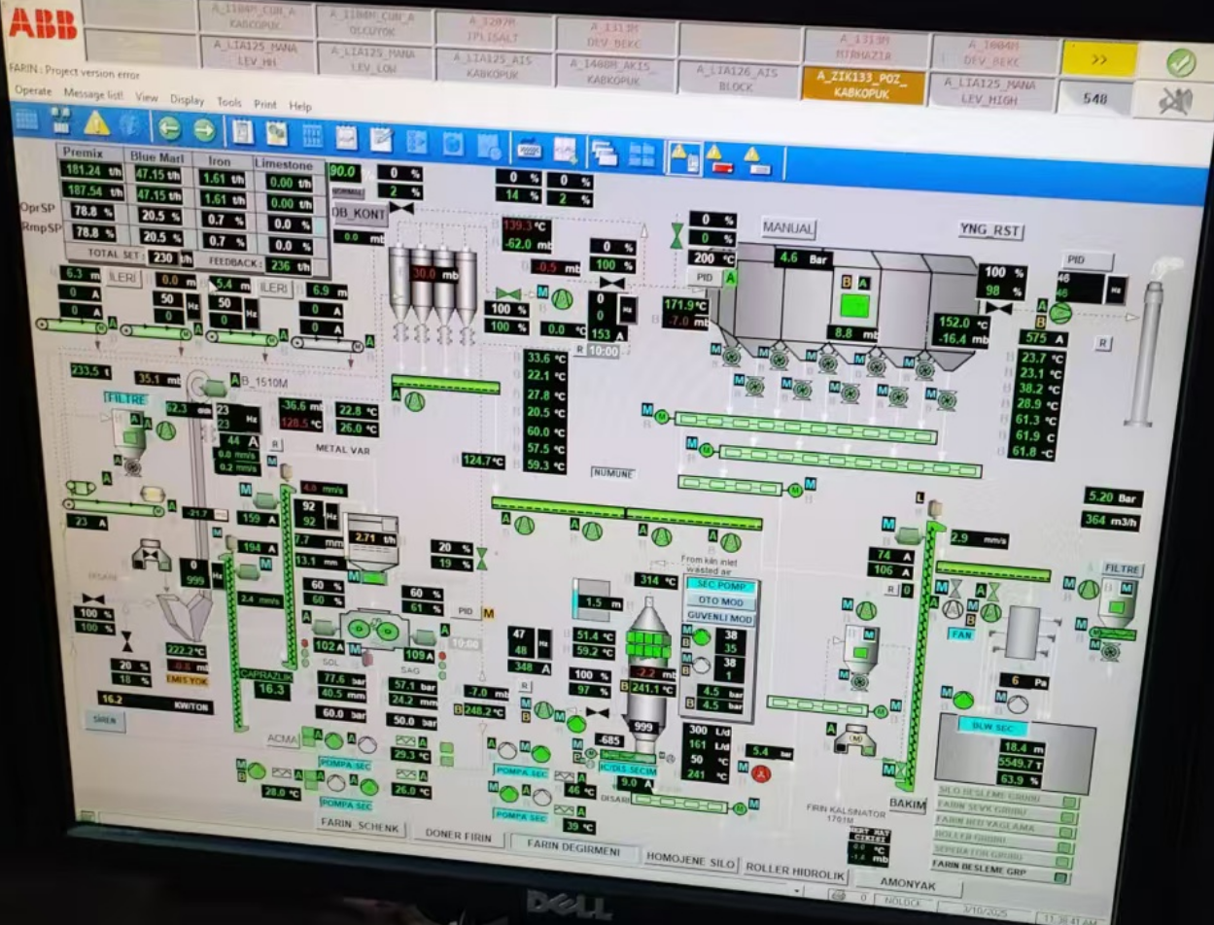
Process Operation System

B System modification measures:
- This renovation involves multiple equipment adjustments and replacements, including modifying the existing roller press body by replacing its motor with a 1400KW model, replacing the torque arm of the existing roller press, adopting a universal coupling of SWC315 specification, and adding an electric feeding device at the inlet.
- Replacing the existing V-Type Separator, reusing its equipment foundation, and newly fabricating connection pipes for the inlet and outlet ports.
- Replacing the existing Dynamic Air Classifier and Cyclone Separators, constructing a new steel platform at elevation 29.000 (the steel platform falls within the Owner’s scope) for installing the new dynamic air classifier and two φ5000mm cyclone separators, as well as newly fabricating the air ducts from the air classifier to the cyclones, from the cyclones to the circulating fan and the material discharge chutes.
- Replacing the circulating fan and its motor, reusing the existing foundation, adjusting the air handling capacity to 580,000 m³/h, with the new motor having a power of 1600KW.
5）15.09 Elevator replace the transmission part, and increase the lifting capacity from 1000tph to 1200tph. Replace the hoist with a V-type powder separator chute, changing it to a four-channel distribution chute.The hot air duct within the system will be upgraded and newly fabricated.

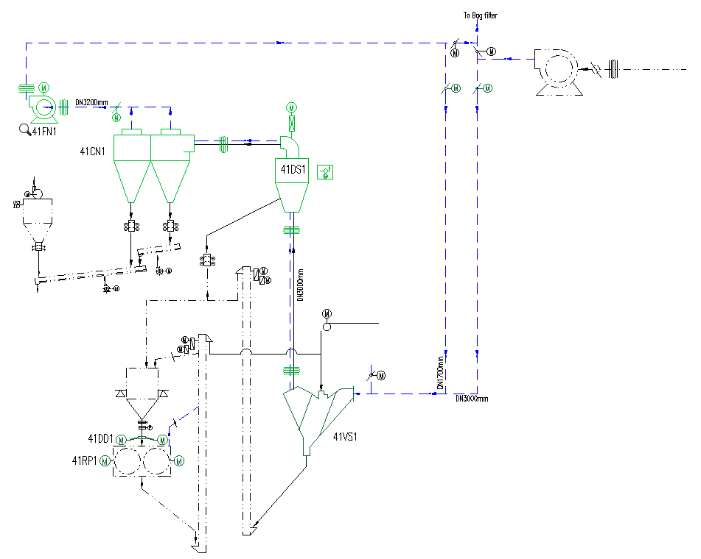

Renovated Process Flowchart
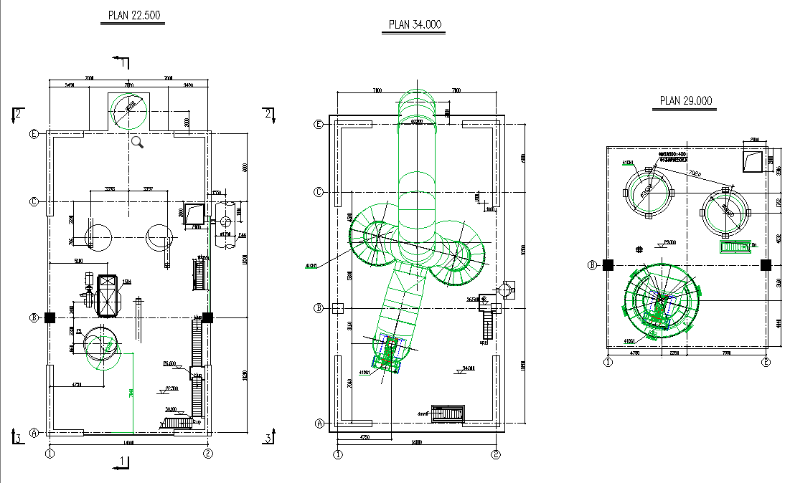

Renovated Workshop Floor Plan

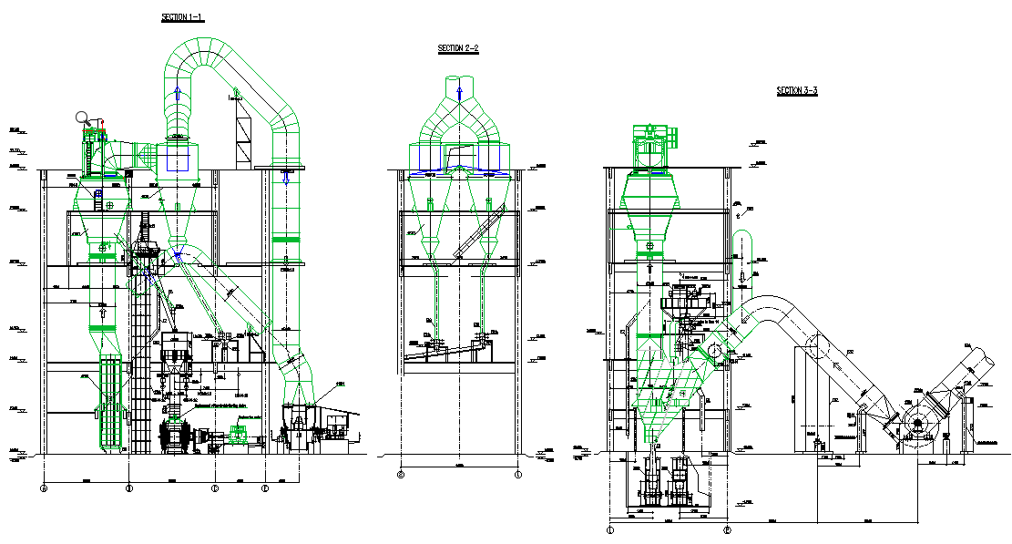
Renovated Cross-Section Diagram

C Electrical Upgrade Plan:
No. | Changes in Equipment Power After Technological Upgrades
1 | The two 1250 kW motors of the roller press have been upgraded to 1400 kW.
2 | The 1400 kW motor of the fan has been upgraded to 1600 kW.
3 | Low Voltage Electrical:  The power of the frequency conversion motor for the powder separator is changed from 90 kW to 185 kW.  A roller press electric distributor is added, with 2 motors of 1.5 kW each.

No. | Scope of Electrical Upgrades
1 | An additional 185KW frequency conversion cabinet has been added to the low pressure section.
2 | Two power distribution circuits and supporting cables are added to the low-voltage part.
3 | Replacement of two water resistance cabinets for the roller press.
4 | An additional high-pressure frequency converter cabinet has been added to the circulating fan.
5 | Modification of the existing high-pressure outgoing cabinet.
6 | Replacement of the matching power cables and control cables.

Chapter 3:Configure List

Please refer to Appendix I: List of Mechanical Equipment

Separator
No. | Technical Specifications | Qty | Power  (kW) | Total Power  (kw) | Place of Origin
41VS1 | Type：PFV10020 | 1 set | / | / | LVSSN
41VS1 | Capacity：250~300t/h
41VS1 | Air volume：500000~600000m³/h
41DS1 | Type：SLR8000 | 1 set | 185 | 185 | LVSSN
41DS1 | Capacity：250~330t/h
41DS1 | Air volume：480000~500000m³/h
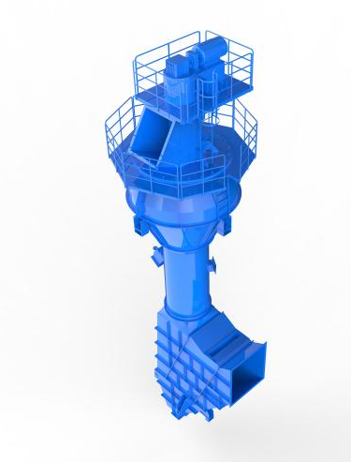 |  | 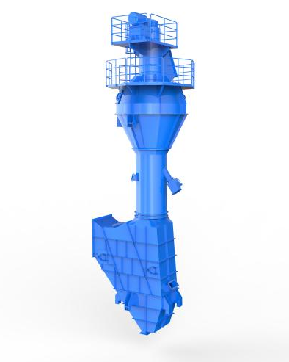

Cyclone
No. | Technical Specifications | Qty | Power  (kW) | Total Power  (kw) | Place of Origin
41CN1 | Size：2-Ф5000mm | 1 set | / | / | LVSSN
41CN1 | Air volume：400000~500000m³/h
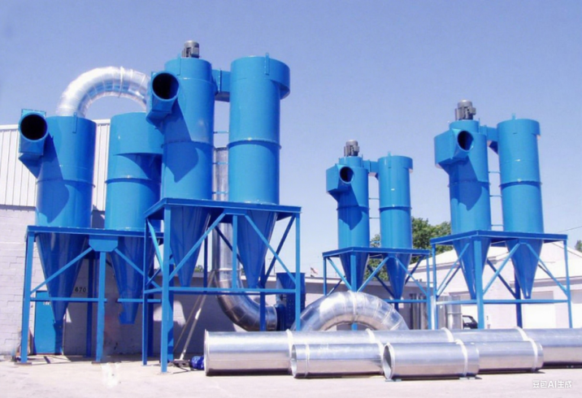
Cyclone

Circulating Fan
No. | Technical Specifications | Qty | Power  (kW) | Total Power  (kw) | Place of Origin
41FN1 | Gas Flow：580000m³/h | 1 set | 1600 | 1600 | LVSSN
41FN1 | Static Pressure：7000Pa
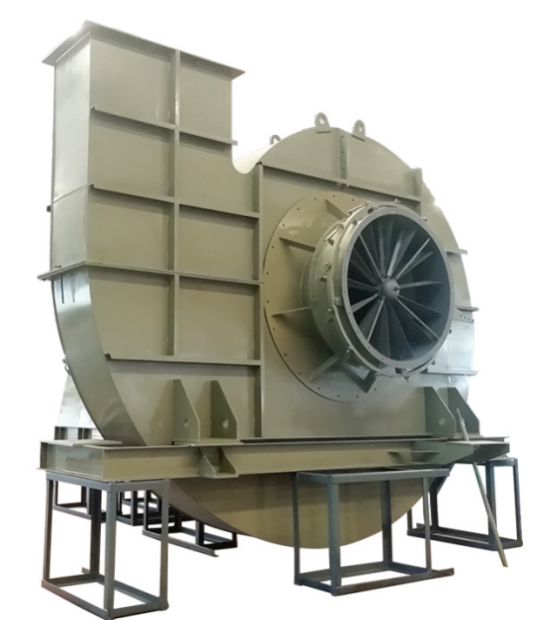
Circulating Fan

Chapter 4:Bill of Quantities
No. | Names of equipment and materials | Model specification | Quantity | Total weight | Remarks
1 | Machinery and Equipment  设备 |  | 1set | 160t | LVSSN
2 | Steel structure  钢结构 |  | 1set | 120t | LVSSN
3 | Non-standard  非标 |  | 1set | 130t | LVSSN
4 | Concrete dismantling  拆除混凝土 |  | 1m³ | 50t | LVSSN
5 | Equipment dismantling  设备拆除 |  | 1set | 120t | LVSSN
6 | Non-standard dismantling  非标管道拆除 |  | 1set | 约100t | LVSSN
7 | Insulation  保温 | 100mm thickness | ~1500m² |  | LVSSN
8 | ELECTRIC  电气系统 |  | 1set |  | LVSSN

Chapter 5:Equipment Suppliers List
No. | Sub-item | Suppliers
1 | V-Type Separator | Jiangsu Lvssn Industrial Equipment Manufacturing Co., Ltd.
2 | Dynamic Separator | Jiangsu Lvssn Industrial Equipment Manufacturing Co., Ltd.
3 | Cyclone | Jiangsu Lvssn Industrial Equipment Manufacturing Co., Ltd.
4 | Electrical louver damper | Jiangsu Lvssn Industrial Equipment Manufacturing Co., Ltd.
5 | Dispersing Device | Jiangsu Lvssn Industrial Equipment Manufacturing Co., Ltd.
6 | Motor | Siemens (China) Co., Ltd
7 | Low voltage VFD | (Siemens,China)  ABB(China)  (Schneider,China)
8 | MV voltage VFD | China

Chapter 6:Corporate Performance

International Projects Contraction
No. | Project | Capacity | Country | Status
1 | OYAK Grinding Plant | 120TPH | Turkiye | E.P
2 | TURKUAZ ATIK YÖNETİMİ YAKIT VE ENERJİ ANONİM ŞİRKETİ | 20TPH | Turkiye | E.P
3 | National Cement Co., Kenya Ltd. 110t/h Cement Grinding Plant Project | 100TPH | Kenya | E.P
4 | National Cement Company  Kaloleni, Kenya（ARM） | 120TPH | Kaloleni, Kenya | E.P
5 | Udomsai Cement Co. 5000t/d Cement Production Line | 5000TPD | Lamo District, Laos | E.P.C
7 | Cement Luangprabang Sole Co.  3000t/d cement clinker production line | 3200TPD | Luang Prabang, Laos | E.P.C
8 | Al Tkamol Cement Company | Coal mill | Sudan | E.P.C
9 | HCC 5000tpd Cement Production Line | 5000TPD | Saudi Arabia | E
10 | AL JOUF Cement Extension Project | 5000TPD | Saudi Arabia | E
11 | TCC 5000TPD Cement Plant Extension Project | 5000TPD | Saudi Arabia | E
12 | GOE Arish Cement Plant Phase II 2x5775 TPD | 5775TPD | Egypt | EPC&  OM
13 | GOE Beni Suef 6x6000tpd Clinker Cement Project | 6000TPD | Egypt | EPC&  OM

Domestic(Recent) Project Contraction
No. | Project | Capacity | Country | Status
1 | 浙浦水泥有限责任公司熟料线改造项目  Zhepu Cement Co., Ltd. Clinker Capacity Increase and Renovation Project | 3000t/d | Yunnan,Suijiang | E.P.C
2 | 浙浦水泥有限责任公司垃圾协同处理工程Zhepu Cement Co., Ltd. Waste Co-Processing Project | 150t/d | Yunnan,Suijiang | E.P.C
3 | 芜湖华杨水泥有限公司熟料生产线技改工程  Wuhu Huayang Cement Co., Ltd. Technical Renovation Project | 1400t/d | Anhui,Wuhu | E.P.C
4 | 淄博中昌特种水泥提产降耗技改工程  Zhepu Cement Co., Ltd. Clinker Production Line Capacity Increase Renovation | 1000t/d | Shandong,Zibo | E.P.C
5 | 恩施金凤生料辊压机系统改造工程  Enshi Jinfeng Raw Meal Roller Press System Renovation Project | 280t/h | Hubei,Enshi | E.P.C
6 | 江西明生水泥有限公司水泥粉磨站项目Jiangxi Mingsheng Cement Co., Ltd. Cement Grinding Station Project | 150t/h | Jiangxi,Mingsheng | E.P.C
7 | 贵州江葛水泥有限公司  Guizhou Jiangge Cement Co., Ltd | 4000t/d | Guizhou ,Meitang | E.P.C
8 | 永平无量山水泥公司  Yongping Wuliangshan Cement Company | 4500t/d | Yunnan,Dali | E
9 | 兆山天全水泥有限公司  Zhaoshan Tianquan Cement Co., Ltd. | 4500t/d | Sichuan,Yaan | E
10 | 奈曼宏基泥有限公司  Naiman Hongji Mud Co., Ltd. | 4500t/d | NeiMenggu,Tongliao | E
11 | 冀东(烟台)水泥有限公司  Jidong (Yantai) Cement Co., Ltd. | 7200t/d | Shandong,Yantai | Construction and equipment installation
12 | 贵州晴隆盘江水泥有限公司  Qinglong pengjiang Cement Co., Ltd | 6000t/d | Guizhou,Qinglong | Construction and equipment installation

Chapter 7:Quotation
No. | Project | Item | Price(RMB) | Remark
1 | Mechanical |  | 260
2 | Engineering design |  | 50
3 | Installation and Demolition |  | 0 | Installation of equipment and non-standard parts
4 | Civil Engineering |  | 0 | Owner's Scope  The design, demolition, construction and strengthening of the civil engineering part
5 | Electrical System Retrofit |  | 0
6 | CIF TURKEY port total amount |  | 0

Note:
1) the quotation not including grease, oil.
2) the quotation not including steel structure, water pipe，Thermal insulation material.
3) The quotation does not include the design, construction, demolition and reinforcement of the civil engineering part.

Chapter 8:Construction Schedule
- The construction plan includes the deployment of 30 installation personnel, working in two shifts of ten hours each. On-site machinery and tools will be arranged in advance.
- The estimated time for equipment dismantling and the removal of concrete beams and slabs is approximately 10 days.
- Non-standard on-site processing, equipment installation, and non-standard pipeline connections are estimated to take around 20 days.
- The entire installation work is guaranteed to be completed within 30 days.

Chapter 9:Payment terms
 | FOB China port
Payment term | 1, %30, Advance payment against advance payment guarantee within 10 days, %70 T/T or irrevocable L/C at sight from world-famous bank issued within 30 days from advance payment date.  2, Negotiation.
Goods Production Time | 100 days from advance payment date.
Packing | Before delivery, the equipment is treated for anti-corrosion. Small parts and electric motor will be put into ply-wood cases; while the large parts are in nude.
Warranty | 100% brand new when leaving the factory. The buyer can inspect goods before delivery. The seller guarantee quality of the machines (excludes spare parts) for a period of one year from the date of trial run finish, but not exceed eighteen months from date at which machines arrive at the port of destination.
Installation, commissioning supervision | After receiving advance payment, the seller will provide the corresponding drawings with the project schedule to the buyer.  According to the installation and commissioning agreement signed by both parties, the LVSSN shall send technician to direct installation, commissioning, trial-run, and training local workers.
Validity | One month from quotation date.

